Q no 2:-

for(var i = 1; i <= 10; i++)

{

console.log( "5 \* " + i + "=" + (5\*i));

}

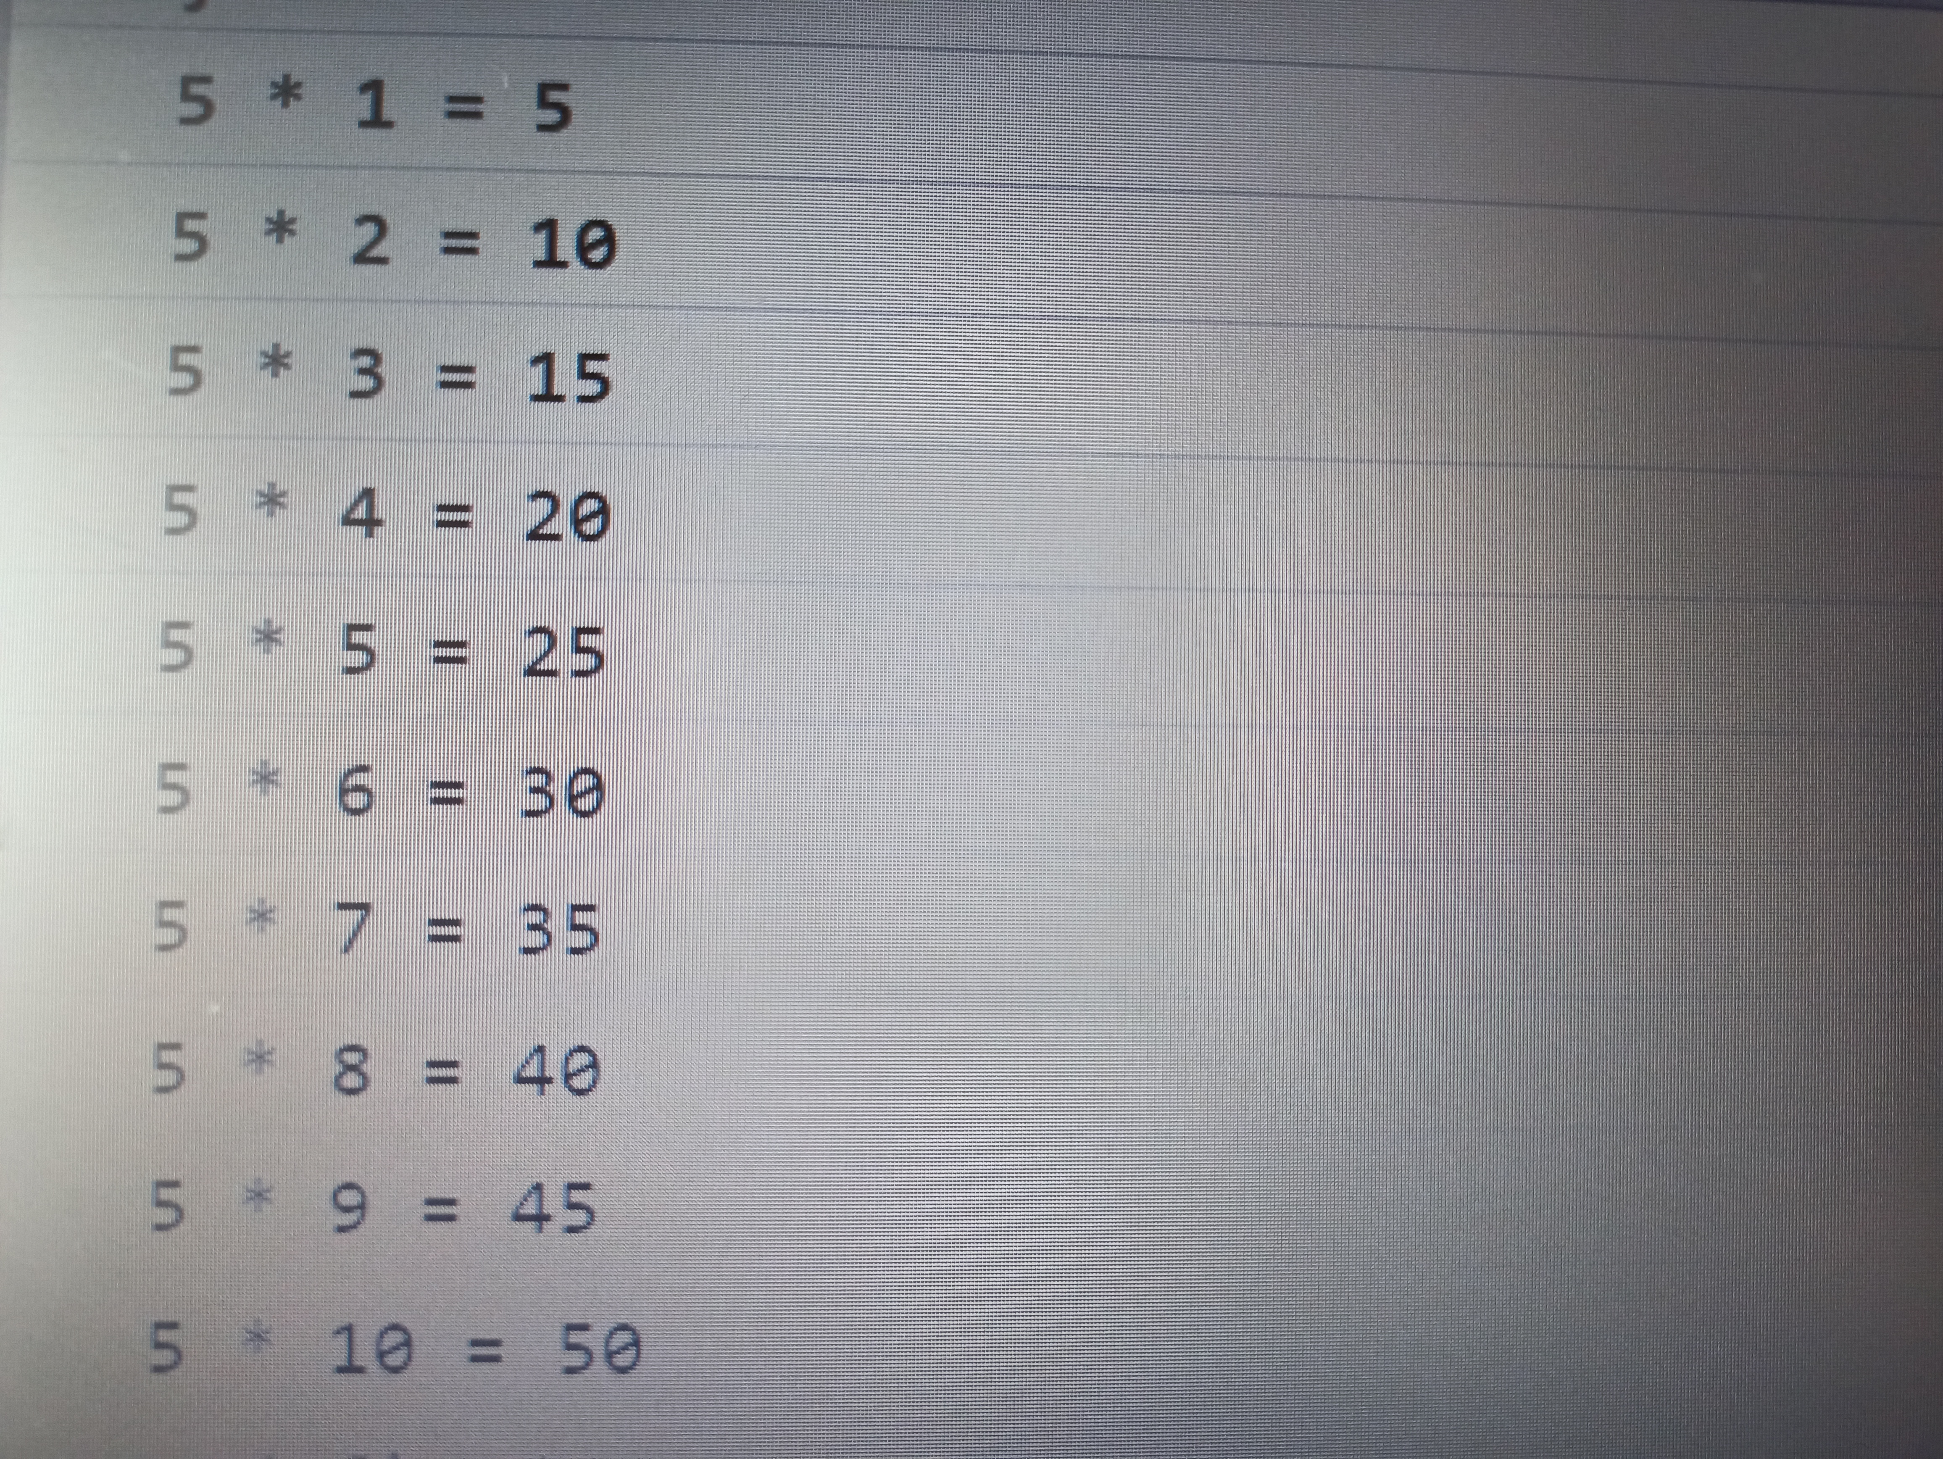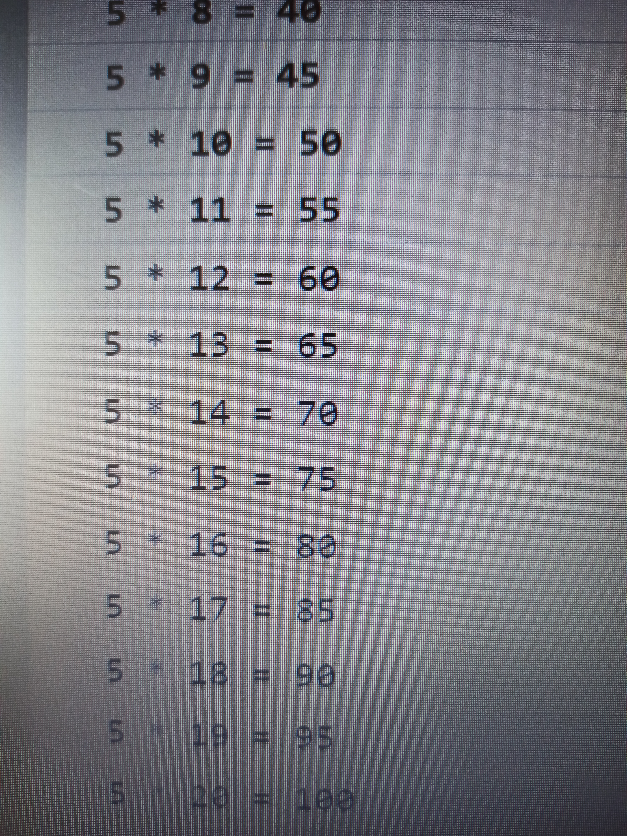

-----------------------------------------------------------------------------------------------------------------------

Q no 1 :-

var marks = 88;

if (marks > 90)

console.log("AA");

else if ( marks > 80 && marks <= 90)

console.log("AB");

else if ( marks > 70 && marks <= 80)

console.log("BB");

else if ( marks > 60 && marks <= 70)

console.log("BC");

else if ( marks > 50 && marks <= 60)

console.log("CC");

else if ( marks > 40 && marks <= 50)

console.log("CD");

else if ( marks > 30 && marks <= 40)

console.log("DD");

else (marks <= 30)

console.log("FF");